Measuring Safety Performance
Guidelines for Service Providers

Executive Summary

The objective of this paper is to provide guidelines for the definition and implementation of a set of safety performance indicators as part of your safety management system.

This document proposes an approach to safety performance measurement aiming at increasing your company’s potential for effective safety management that considers systemic and operational issues. Effective safety performance measurement will be decisive in driving your safety management system towards excellence.

Throughout this document:
- any reference to the term 'service provider' is intended to cover providers of aviation products and services;
- any reference to 'operations' is intended to mean your core activities being regulated through aviation safety regulations; and
- any reference to 'regulator' is used in the broad sense, to cover all State functions and responsibilities as relevant for the management of aviation safety.

Terms and definitions used throughout this document consider definitions contained in International Civil Aviation Organization (ICAO) Annex 19 Edition 1 and the Safety Management International Collaboration Group (SM ICG) Safety Management Terminology paper.

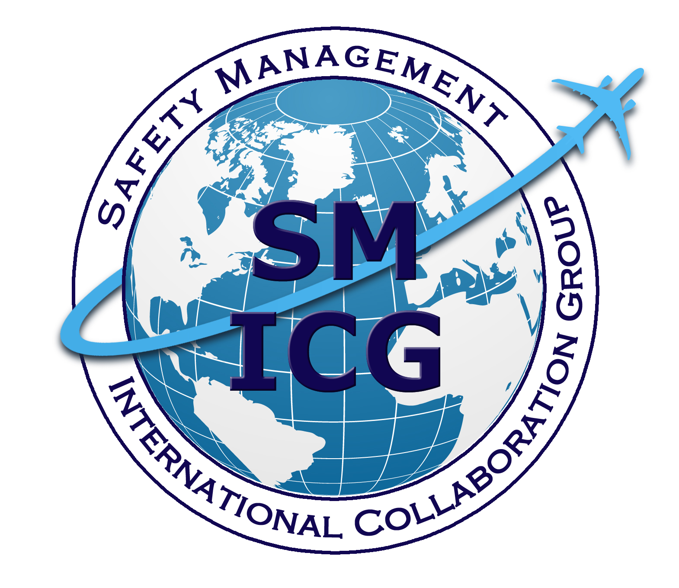
July 16, 2013

Table of Contents

_Toc361765674
1. The concept 2
1.1. What is safety performance? 2
1.2. Why measure safety performance? 3
1.3 How to measure: types of safety performance indicators 5
2. Safety performance measurement process 7
2.1. Prerequisites for effective safety performance measurement 7
2.2. Process for defining and reviewing safety performance indicators 8
3. SPI examples 13
3.1. Indicators for systemic issues 13
3.2. Indicators for operational issues 17
3.3. Indicators to monitor external factors 20
Reference documents 22

1. The concept

What is safety performance?

ICAO Annex 19 defines safety as ‘the state in which risks associated with aviation activities, related to, or in direct support of the operation of aircraft, are reduced and controlled to an acceptable level’ and safety performance as ‘a service provider’s safety achievement as defined by its safety performance targets and safety performance indicators’. These definitions provide a good indication of the complexity related to measuring safety performance. In many areas safety metrics tend to focus on serious incidents and accidents, as these are easy to measure and often receive more attention. In terms of safety management, the focus on such negative events should be considered with some caution, because:
- in systems such as aviation with a low number of high consequence negative outcomes, the low frequency of such outcomes may give the wrong impression that your system is safe;
- the information is available too late to act on it;
- counting final outcomes will not reveal any of the systemic factors, hazards or latent conditions that have a potential to result in high consequence negative outcomes, under the same conditions; and
- where the resilience of a system has been undermined, such outcomes are more likely to occur by chance and therefore these outcomes may draw unwarranted attention and use scarce resources when they are not predictive of later events.

The issue is further complicated because the aviation system is a highly dynamic, complex system with many different players, interactions, dependencies and parameters that may have a bearing on final safety outcomes. Therefore, in most cases it is impossible to establish a linear relationship between specific parameters or safety actions and the final, aggregate safety outcome. Hence, the absolute measurement of safety is itself unachievable. Whilst there are many models of what makes up the level of safety (and conversely the level of exposure to risk), indicators will always constitute imperfect markers of these levels.

Safety is more than the absence of risk; it requires specific systemic enablers of safety to be maintained at all times to cope with the known risks, to be well prepared to cope with those risks that are not yet known, and to address the natural ‘erosion’ of risk controls over time. Thus, from the perspective of your company there cannot be any direct measures of safety.

Measures should in particular focus on those features of your system that are intended to ensure safe outcomes —those elements that will constitute organizational enablers of safe outcomes and specific safety controls and barriers for any risks identified. Measures also need to address how external factors may influence these enabling elements, risk controls and barriers or how these controls and barriers influence each other. This approach is aligned with current industry practice in the area of quality management as promoted for example by International Organization for Standardization (ISO) 9000 series standards; when the resulting output cannot be directly measured, the underlying systems and processes need to be validated instead.

The principles above are valid both from a regulator’s perspective and from the perspective of an individual service provider; in all cases the dynamic nature of the systemic, operational and external components of safety performance should be considered.

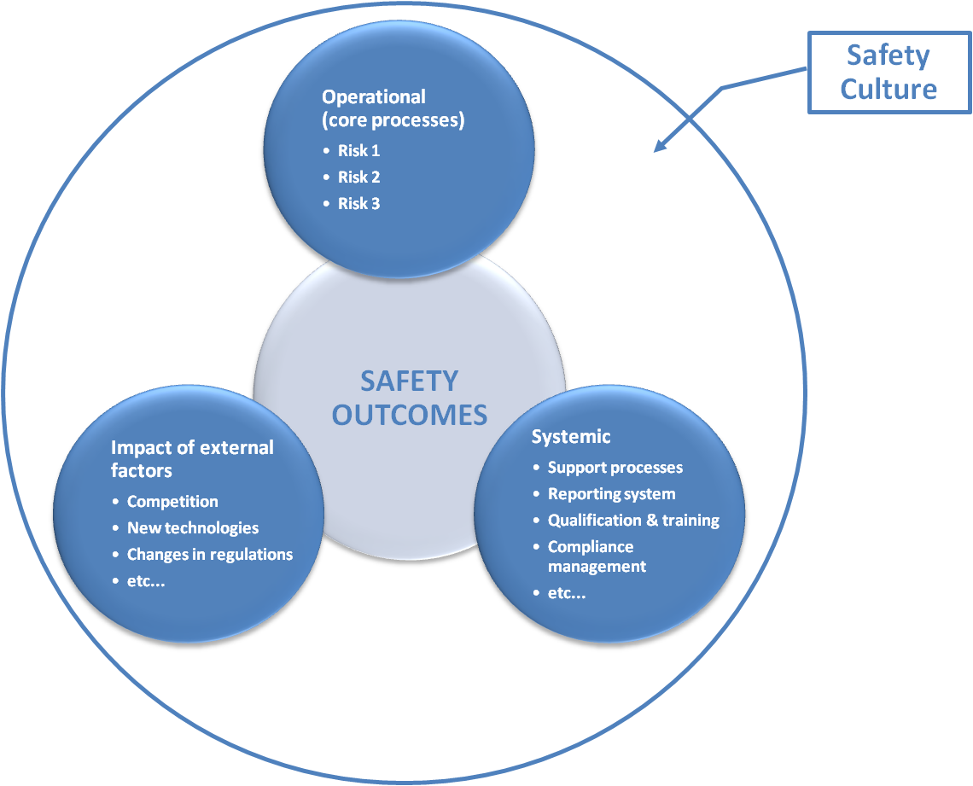

Figure 1: Components of safety performance

Why measure safety performance?

ICAO Safety Management System (SMS) standards and recommended practices promote the development and maintenance of means to verify the safety performance of your organization and to validate the effectiveness of safety risk controls.

The analysis and assessment of how your company ‘functions’ to deliver its activities should form the basis for defining your safety policy, the related safety objectives and the corresponding safety performance indicators and targets.

SMS requires a systemic approach as with any other element of business management (e.g., quality, finance), and in this respect safety performance measurement provides an element that is essential for management and effective control: 'feedback.'

- Feedback will allow management to validate the analysis and assessment of how well your organization functions in terms of safety and to make adjustments as required (Plan-Do-Check-Act).
- Feedback to your management will guide decision-making and resource allocation.
- Feedback to all staff will ensure that everyone is informed on your company’s safety achievements. This will help to create commitment and contribute to fostering your company’s safety culture.

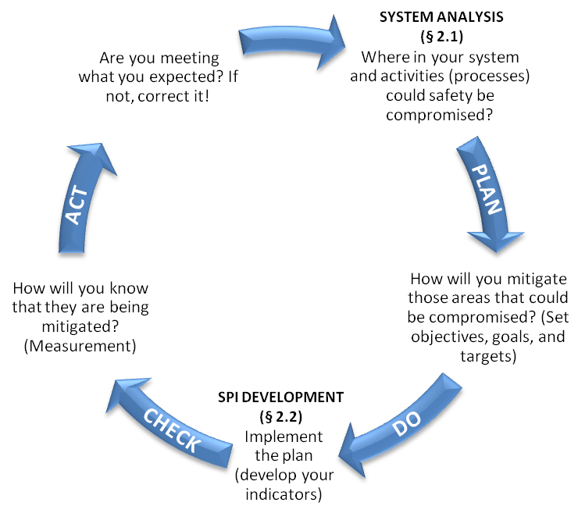
Figure 2: The measurement cycle

Effective safety performance measurement will support the identification of opportunities for improvement not only related to safety, but also to efficiency and capacity.

The management of safety relies on the capabilities of your organization to systematically anticipate, monitor, and further develop your organizational performance to ensure safe outcomes of your activities. Effective safety management requires a thorough understanding and sound management of your system and processes. This cannot be achieved without some form of measurement. Rather than randomly selecting outcomes that are easy to measure, you should select safety performance indicators that consider the type of feedback needed to ensure your company’s capabilities for safety management can be properly evaluated and improved. This implies that you will need to measure performance at all levels of your organization by adopting a broad set of indicators involving key aspects of your system, and operations and allowing to measure those key aspects in different ways.

How to measure: types of safety performance indicators

ICAO defines safety performance indicator as ‘a data-based safety parameter used for monitoring and assessing performance’ and safety performance target as ‘the planned or intended objective for safety performance indicator(s) over a given period.’

Safety performance indicators (SPIs) can be ‘classified’ in accordance with specific features; and different classifications are commonly used in different areas. The types of indicators described in this document have been defined following a review of such commonly used classifications and definitions to identify commonalities. An explanation is provided where relevant on the use of each. You may adopt any terms for your specific safety performance indicators as you see fit; the information below is provided to complement the conceptual information required for effective safety performance measurement.

- Lagging indicator

‘Metrics that measure safety events that have already occurred including those unwanted safety events you are trying to prevent’ (SM ICG).

Lagging indicators are measures of safety occurrences, in particular the negative outcomes that the organization is aiming to prevent. Lagging indicators are mainly used for aggregate, long-term trending, either at a high level or for specific occurrence types or locations. Because they measure safety outcomes, they can be used to assess the effectiveness of safety measures, actions, or initiatives and are a way of validating the safety performance of the system. Also, trends in these indicators can be analyzed to determine if latent conditions exist in present systems that should be addressed.

Two types of lagging indicators are generally defined as:

- Indicators for high severity negative outcomes, such as accidents or serious incidents.

The low frequency of high severity negative outcomes means that aggregation (e.g., at industry segment level or regional level) may produce more meaningful analyzes.

Example: number of runway excursions/1000 landings.

- Indicators for lower level system failures and safety events that did not manifest themselves in serious incidents or accidents (including system failures and procedural deviations); however, safety analysis indicates there is the potential for them to lead to a serious incident or accident when combined with other safety events or conditions. Such indicators are sometimes referred to as ‘precursor event’ indicators.

Indicators for lower level system failures and safety events are primarily used to monitor specific safety issues and measure the effectiveness of safety controls or barriers put in place for mitigating the risk associated with these hazards.

Example: number of unstabilized approaches/1000 landings

- Leading indicator

‘Metrics that provide information on the current situation that may affect future performance’ (SM ICG).’

Leading indicators should measure both: things that have the potential to become or contribute to a negative outcome in the future (‘negative’ indicators), and things that contribute to safety (‘positive’ indicators). From a safety management perspective, it is important to provide sufficient focus on monitoring positive indicators to enable strengthening of those positive factors that make up your company’s safety management capability.

Leading indicators, which are particularly relevant from a management perspective, may be used to influence safety management priorities and the determination of actions for safety improvement. You may use this type of indicator to proactively develop (‘drive’) your company’s safety management capabilities, in particular during initial implementation of SMS. This may entail the setting of performance targets.

Example: The percentage of changes to Standard Operating Procedures that have been subject to hazard identification and safety risk management

Leading indicators may also be used to inform your management about the dynamics of your system and how it copes with any changes, including changes in its operating environment. The focus will be either: on anticipating emerging weaknesses and vulnerabilities to determine the need for action, or on monitoring the extent to which certain activities required for safety are being performed. For these ‘monitoring’ indicators, alert levels can be defined.

Example: The extent to which work is carried out in accordance with Standard Operating Procedures

The concept of leading and lagging indicators has existed in domains outside of aviation for a number of years. In particular, economists use them as a means to measure the health of an economy.

Safety performance measurement should ideally consider a combination of leading and lagging indicators. The main focus should be to measure and to act upon the presence of those systemic and operational attributes that enable effective safety management within your company and meanwhile, use lagging indicators to ensure that this safety management is effective. Lagging indicators, particularly indicators for lower level system failures, are useful to validate the effectiveness of specific safety actions and risk barriers or to support the analysis of information derived from your leading indicators.

2. Safety performance measurement process

2.1. Prerequisites for effective safety performance measurement

In essence, your safety performance is determined by your capability to implement and maintain those organizational elements required to ensure safe outcomes. The purpose of your SMS is to build up, maintain, and continually improve this capability. As a prerequisite for effective safety management, your organization needs to perform a system analysis to generate an accurate and reliable description of your organizational structures, policies, procedures, processes, staff, equipment, and facilities. This analysis should have a particular focus on the interactions between system components and external factors. This will provide you with a model of how your system elements and activities interact to produce the expected safety outcomes, allowing you to identify the strengths and weaknesses of your system. The system description and related model of how your activities lead to the expected outcomes will inform you on what to measure to drive safety performance and what to monitor to keep an eye on all of those elements that may affect your organization’s safety performance.

Guidance on system description and hazard identification for design and manufacturing organizations may be found for example in the Federal Aviation Administration (FAA) Aircraft Certification Service (AIR) SMS Pilot Project Guide. Most of the elements developed in this guidance document can be adapted for other sectors. Although designed for regulators, the SM ICG SMS Evaluation Tool may be useful in assessing the completeness and adequacy of your SMS. Your internal audit system and regulator audits and inspections may also identify areas of concern or safety critical tasks.

If your organization has a quality management system, such as those defined in ISO 9001/AS9100 or equivalent standards, the existing system and process description is a starting point for your system analysis, but you should ensure that your system and process description properly addresses aviation safety risks as well as business risks.

Following completion of the system description, including analysis and assessment, your company should have gained or confirmed its understanding of where it stands with regard to safety. Through this exercise you should have identified:

At the systemic level:
- whether the elements that constitute enablers of effective safety management are present, suitable, and effective;
- the elements that are still missing for effective safety management;
- whether the elements are sufficiently integrated with each other and with the core management and operational processes of your organization; and
- the weaknesses and vulnerabilities in your organization.

At the operational level:
- the main risks in operations that need to be addressed (the things that may cause ‘your next accident’).

This will form the basis for reviewing the adequacy of your safety policy, defining or adapting your safety objectives, and deriving your safety performance indicators.

2.2. Process for defining and reviewing safety performance indicators

As with anything that relates to effective safety management, defining and using safety performance indicators must be a dynamic process. A step-by-step process for developing your own set of safety performance indicators is proposed, which follows the ‘Plan-Do-Check-Act’ logic for continual improvement. This should help you to involve and get buy-in from all staff concerned.

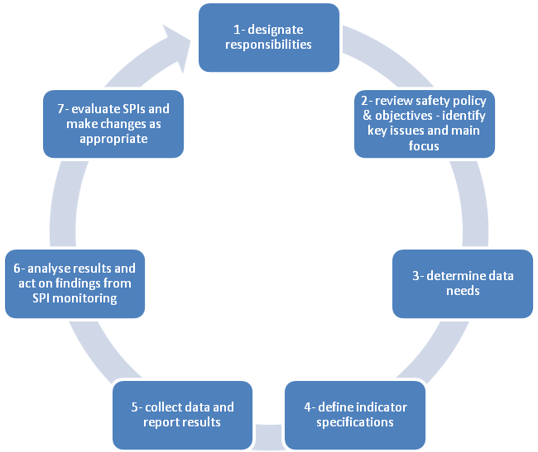

Figure 3: Process steps

Step 1: Designate responsibilities

It is critical to the success of the SPI project, as to the SMS journey in general, that your management are fully committed to implementing SPIs as a fundamental part of your company’s safety management approach. Rather than just supporting a system of SPIs, management must define aspects of your organization that require measurement and management and then must commit to a systematic approach to managing those elements, in accordance with your safety policy and defined safety objectives.

The first step for establishing SPIs will be for management to designate personnel with responsibilities for initiating the effective promotion and coordination of the introduction of the SPIs. This will require responsibility for ensuring effective communication and generally overseeing the implementation, with due consideration of your existing organizational setup in relation to safety management. These personnel (hereafter referred to as ‘SPI team’) should ideally include, and certainly have access to, personnel with appropriate experience and knowledge of safety and/or quality management principles and data analysis. They should also have experience applying this knowledge and these skills in the context of your policies, programs, operational procedures and practices. Process owners must be directly involved even if ‘specialists’ are used to supply measurement expertise or to support/facilitate the SPI development process. Also, it is essential that process owners take ownership of safety performance measurement for their processes. The SPI team (or individual with designated responsibilities, depending on the size and complexity of your organization) must clearly be shown to be in either a support or advisory role to management and process owners.

Management should be kept informed of progress on a regular basis and should take an active role in steering the process of implementing SPIs. For larger organizations it may be useful to develop an analysis of the costs and benefits of the SPI development project, with particular focus on the positive effects on your company’s ‘management information system’ that will lead to improved resource allocation.

Finally the SPI team should set a reasonable timetable, including milestones, to ensure adequate progress in developing the SPIs.

Step 2: Review safety policy and objectives – identify key issues and main focus

At this step, the SPI team should identify the scope and focus of measurement considering the results of the system analysis (cf. § 2.1), paying particular attention to the completeness and adequacy of your SMS.

To define indicators for specific operational safety issues, the bow-tie methodology or similar tools can be used to determine the safety actions and risk barriers that would be most suitable for the definition of operational SPIs. A thorough hazard identification will be required as part of your system analysis to provide a good understanding of threats to safety in your operations.

The SPI team may also review typical indicators used within your industry segment and assess them to determine whether they are pertinent to your organization. For example, measuring the number of internal reports may not be meaningful if your system analysis reveals that there are no easily accessible means to report or there are concerns about confidentiality.

Step 3: Determine data needs

To be meaningful, measures of performance must be based on reliable and valid data, both qualitative and quantitative. Therefore the SPI team should identify all pertinent data and information that is available within your company and determine what additional information is needed. It should also consider information available through the internal audit/compliance monitoring system.

Regardless of the type of data, quality is one of the most important elements in ensuring that the data can be integrated and used properly for analysis purposes. Data quality principles and practices should be applied throughout the processes from data capture and integration to analysis. Guidance about required data attributes and data management can be found in the SM ICG ‘Risk Based Decision Making Principles’ document.

You may be tempted to identify things that lend themselves to being measured instead of identifying what you should measure. This is likely to result in identifying SPIs that are most obvious and easy to measure rather than SPIs that are most valuable for effective safety management. Therefore, at this step of the process, it is important to focus on what changes your organization wants to ‘drive’ and what aspects it needs to ‘monitor.’ You should also consider that, to be effective at assessing system safety, a broad set of indicators involving key aspects of your system and operations should be developed; this will reduce the possibility of having a narrow and therefore potentially flawed view of your company’s safety performance.
Also, it may be necessary to measure the same system in several ways in order to gain a more precise idea of the actual level of safety performance. For example, only assessing your company’s safety culture without measuring operational parameters will merely provide a very partial indication of safety performance.

In the area of hazard identification and risk management in operations (core processes), availability of data will depend in part on the maturity of your internal safety reporting schemes. Aggregate data for your industry segment may also be considered, particularly when your SMS has not yet generated sufficient data. Other information, such as number of flights, fleet size, and financial turnover, may contribute to a better understanding of the context of operations. Continuous availability of data should be ensured to generate relevant and timely indicators. Delays in compiling data for the generation of indicators are likely to delay any safety actions that may be required.

Step 4: Define indicator specifications

Once the scope and focus of your SPIs have been determined and available data/information reviewed, the specifics need to be defined. Each SPI should be accompanied by sufficient information (or metadata) which enables any user to determine both the source and quality of the information, and place this indicator in the context necessary to interpret and manage it effectively.

Whenever possible, indicators should be quantitative, as this facilitates comparison and detecting trends. Quantitative metrics should be precise enough to allow highlighting trends in safety performance over time or deviations from expected safety outcomes or targets.

For qualitative SPIs, it is important to minimize subjectivity. This may be achieved through an evaluation by members of staff not directly involved in the definition of SPIs.

Depending on the size of your company and the complexity of your activities, a hierarchical framework for your SPIs could be defined to reflect the different processes and sub-systems within your organizational structure. While some indicators for assessing systemic issues may be common to different processes and subsystems, indicators for assessing operational issues will need to be specific. This underlines the importance of having performed an accurate system analysis identifying all system components and sub-systems as a prerequisite for implementing SMS (cf. § 2.1).

Aspects of good SPIs include :
- The indicator is:
  - valid and reliable,
  - sensitive to changes in what it is measuring, and
  - not susceptible to bias in calculating or interpretation.
- Capturing the data is cost effective.
- The indicator is:
  - broadly applicable across company operations, and ideally throughout the larger aviation sector, and
  - easily and accurately communicated.

Step 5: Collect data and report results

Once you have defined your SPIs, you must decide how you will collect the data and report the results. Data collection approaches (i.e., data sources, how data will be compiled, and what the reports will look like), as well as roles and responsibilities for collection and reporting, should be specified and documented. Data collection procedures should also consider the frequency with which data should be collected and the results reported for each SPI. Some of these issues will have been addressed when deciding on the SPIs in steps 3 and 4.

The presentation format of the indicator results should take into account the target audience. For example, if you track several indicators addressing the same key issue, it may be useful to identify a subset of the most critical indicators to be given greater emphasis for reporting to top management. The presentation of indicator results should facilitate understanding of any deviations and identification of any important trends (e.g., scoreboards with traffic lights, histograms, linear graphs).

Step 6: Analyze results and act on findings from SPI monitoring

This is the most relevant step in terms of safety management, as the ultimate goal of implementing SPIs is to maintain and improve your company’s safety performance over time. There is no point in collecting information if the results are not used. Remember that SPIs are indicators of safety performance, not direct measures of safety. The information collected through different SPIs needs to be carefully analyzed, and SPIs collected for different issues need to be put in perspective and the results interpreted, so as to gain an overall picture of the organization’s safety performance. The results obtained through an individual indicator may be insignificant if taken in isolation, but may be important when considered in combination with other indicators.

Inconsistencies between SPIs may be an indication of an inaccurate system description or problems with the SPIs themselves. For example, you may encounter situations where leading and lagging indicators associated with the same safety issue provide contradictory results or where a positive trend in systemic indicators goes with a negative trend in operational indicators.

If you find that the metrics are not defined well enough to capture safety critical information the SPIs should be reviewed. Any inconsistencies in the overall picture represent a potential opportunity for learning and for adjusting not only the SPIs (see Step 7) but your SMS itself.

Indicators should not be simply seen as a metric, with actions being taken to get a good score rather than to improve safety performance. It is important that results obtained through the collection, analysis and interpretation of SPIs are conveyed to your management for decision and action. Ideally, these results should be presented at regular meetings (e.g., management reviews, safety review board meetings) to determine what actions are required to address deficiencies or to further improve the system. It is important that such actions do not focus on certain indicators in isolation, but on optimizing your organization’s overall safety performance.

As part of your safety communication and promotion, all staff should be informed of the results obtained through the collection, analysis, and interpretation of SPIs.

Step 7: Evaluate SPIs and make changes as appropriate

The systems analysis of your organization, along with the set of SPIs and their specifications, including the metrics and any defined targets, should be periodically reviewed and evaluated to consider:
- the value of experience gained,
- new safety issues identified,
- changes in the nature of risk,
- changes in the safety policy, objectives; and priorities identified,
- changes in applicable regulations, and
- organizational changes, etc.

The frequency of the review cycle should be defined. Periodic reviews will help to ensure that the indicators are well defined and that they provide the information needed to drive and monitor safety performance. Periodic reviews will also help identify when specific ‘drive’ indicators are no longer needed (e.g., if the intended positive changes have been achieved) and allow adjustment of SPIs so that they always focus on the most important issues in terms of safety. Nevertheless, too frequent reviews should be avoided, as they may not allow establishing a stable system.

After the first two to three cycles, you should have collected enough data and gained sufficient experience to be able to determine which are your ‘key’ SPIs - those that are most valuable and most effective to monitor and to drive safety performance. At this stage you may be able to derive targets for these key SPIs by extrapolating the data collected during previous cycles. Any such extrapolation needs to consider the ‘dynamics’ of your organization. You might also compare your SPIs with those implemented by other organizations within your industry segment, but you should never simply copy another organization’s SPIs without checking that they are meaningful for your organization.

3. SPI examples
Below is a non-exhaustive list with examples of indicators intended to assist your organization with selecting your own set of safety performance indicators, following the process described in § 2.2. Before adopting any of these as your own SPIs, you should determine if the particular indicator is relevant to your specific organization, considering the maturity of your SMS and the specific features you would like to improve or that need attention.

3.1. Indicators for systemic issues

Area | Focus of measurement | Metrics
Compliance | - internal audits/compliance monitoring: all non- compliances | - total number per audit planning cycle / trend  - % of findings analyzed for their safety significance,
 | - internal audits/ compliance monitoring: significant non-compliances | - number of significant findings versus total number of findings  - number of repeat findings within audit planning cycle
 | - internal audits/ compliance monitoring: responsiveness to corrective action requests | - average lead time for completing corrective actions per oversight planning cycle - trend
 | - external audits/ compliance monitoring: all non- compliances | - total number per oversight planning cycle / trend  - % of findings analyzed for their safety significance,
 | - external audits: significant non-compliances | - number of significant findings versus total number of findings
 | - external audits: responsiveness to corrective action requests | - average lead time for completing corrective actions per oversight planning cycle - trend
 | - consistency of results between internal and external audits/compliance monitoring | - number of significant findings only revealed through external audits
SMS effectiveness | - strategic management | - the degree to which safety is considered in the organization’s official plans and strategy documents  - the frequency with which the organization’s official plans and strategy documents are reviewed with regards to safety
 | - management commitment | - number of management walk-arounds per month/quarter/year  - number of management meetings dedicated to safety per month/quarter/year
 | - turnover rate of key safety personnel | - length of term  - number of cases where the reasons for departure of key personnel have been analyzed
 | - supervision | - number of cases where supervisors provided positive feedback on safety-conscious behavior of your staff per month/quarter/year
 | - reporting | - number of reports received per month/quarter/year & trend  - % of reports for which feedback to reporter was provided within 10 working days  - % of reports followed by an independent safety review
 | - hazard identification | - number of accident/serious incident scenarios analyzed to support Safety Risk Management (SRM) per month/quarter/year  - number of new hazards identified through the internal reporting system per month/quarter/year & trend  - findings from external audits concerning hazards that have not been perceived by personnel/ management previously  - number of safety reports received from staff per month/quarter/year & trend
 | - risk controls | - number of new risk controls validated per month/quarter/year  - % of overall budget allocated to new risk controls
 | - HR management & competence development | - % of staff for which a competence profile has been established  - % of staff who have had safety management training  - frequency for reviewing competence profiles  - frequency of reviewing the scope, content, and quality of training programs  - number of changes made to training programs following feedback from staff per month/quarter/year  - number of changes made to training programs following analysis of internal safety reports per month/quarter/year
 | - management of change | - number of organizational changes for which a formal safety risk assessment has been performed per month/quarter/year & trend  - number of changes to Standard Operating Procedures (SOPs) for which a formal safety risk assessment has been performed per month/quarter/year & trend  - number of technical changes (e.g., new equipment, new facilities, new hardware) for which a formal safety risk assessment has been performed per month/quarter/year & trend  - number of risk controls implemented for changes per month/quarter/year & trend  - % of changes (organizational/SOP/technical etc.) that have been subject to risk assessment
 | - management of contractors | - % of contractors whose safety performance has been assessed  - frequency for assessing safety performance of contractors  - % of contractors integrated with your company’s safety reporting scheme  - % of contractors for which safety training has been provided  - % of contractors that have implemented training control procedures  - % of contractors that have a feedback system on safety issues in place with their customer  - number of safety reports received from contractors per month/quarter/year & trend  - number of safety actions initiated following assessment of safety performance or safety reports received per month/quarter/year & trend
 | - emergency response planning (ERP) | - number of emergency drills per year  - frequency of reviewing the ERP  - number of trainings on ERP per month/quarter/year  - % of staff trained on the ERP within a quarter/year  - number of meetings with main partners and contractors to coordinate ERP per month/quarter/year
 | - safety promotion | - number of safety communications published  - number of trainings performed  - number of safety briefings performed.  - (per month/quarter/year)
 | - safety culture | - the extent to which personnel consider safety as a value that guides their everyday work (e.g., on a scale from 1= low to 5=high)  - the extent to which personnel consider that safety is highly valued by their management  - the extent to which human performance principles are applied  - the extent to which the personnel take initiatives in improving organizational practices or report problems to management  - the extent to which safety-conscious behavior is supported  - the extent to which staff and management are aware of the risks your operations imply for themselves and for others.

3.2. Indicators for operational issues

Area | High Severity outcome to be prevented | Metrics
Air operators  See also  Air Traffic management/ Air Navigation Services  for additional indicators | - traffic collision | - number of Traffic Collision Avoidance System (TCAS) resolution advisories per 1000 flight hours (FH)
 | - runway excursion | - number of unstabilized approaches per 1000 landings
 | - ground collision | - number of runway incursions per 1000 take-offs
 | - controlled flight into terrain | - number of Ground Proximity Warning System (GPWS) and Enhanced Ground Proximity Warning System (EGPWS) warnings per 100 take-offs
 | - accident/incident related to poor flight preparation | - number of cases where flight preparation had to be done in less than the normally allocated time  - number of short fuel events per 100 flights  - number of fuel calculation errors per 100 flights
 | - accident/incident related to fatigue | - number of extensions to flight duty periods per month/quarter/year & trends
 | - accident/incident related to ground-handling | - number of incidents with ground handlers per month/quarter/year & trends  - number of mass and balance errors per ground handler per month/quarter/year & trends  - number of dysfunctions per ground handler per month/quarter/year & trends
 | - maintenance related accident/incidents | - Pilots Reports (PIREPS) per 100 take offs  - deferred items per month and aircraft  - In Flight Shut Down (IFSD) per 1000 FH  - In Flight Turn Backs (IFTB) and deviations per 100 take offs  - number of service difficulty reports filed with the Civil Aviation Authority  dispatch reliability:  - number of delays of more than 15 minutes due to technical issues per 100 take offs  - number of cancellations per 100 scheduled flights due to technical issues  - rejected take offs per 100 take offs due to technical issues
Maintenance organizations | - maintenance planning/rostering related accident/incidents | - % of work orders for which a detailed planning has been made
 | - maintenance planning/rostering related accident/incidents | maintenance engineer fatigue / maintenance error:  - % of work orders with a difference > 10% between the expected lead time and the actual processing time  - % of work orders with a difference > 10% between the estimated work force and the actual needs
 | - maintenance related accident/incidents | maintenance error:  - % of work orders that required re-work  - number of duplicate inspections that identified a maintenance error
 | - maintenance data related accident/incidents | - number of safety reports related to ambiguous maintenance data
 | - maintenance related accident/incidents | - number of investigations performed following components removed from service significantly before expected life limit was reached
Air Traffic management/ Air Navigation Services | - traffic collision | - number of level busts/exposure  - number of TCAS required action (RA) (with and without loss of separation) /exposure  - number of minimum separation infringement/exposure  - number of inappropriate separation (airspace in which separation minima is not applicable) /exposure  - number of aircraft deviation from air traffic control (ATC) clearance/exposure  - number of airspace infringements/exposures
 | - traffic collision / controlled flight into terrain | - number of aircraft deviations from air traffic management (ATM) procedures/exposure  - number of inappropriate or absences of ATC assistance to aircraft in distress
 | - controlled flight into terrain | - number of near Controlled Flight Into Terrain (CFIT) IFSD /exposure
 | - runway excursion | - number of inappropriate ATC instruction (no instruction, wrong information, action communicated too late, etc.)
 | - runway incursion | - % of runway incursions where no avoiding action was necessary  - % of runway incursion where avoiding action was necessary
Airports | - post-accident/incident fire | - Fire Extinguishing Services (ICAO Airport Fire Fighting Categories) decrease in value (# decrease- hours/ # airport annual operating hours)  - number of radio/phone failures per 100 operations  number of fire rescue vehicles failures per 100 operations
 | - runway incursion | - runway incursions per 1000 operations  signage:  - number of failures or defects found during routine inspection  - number of defects reported  - average lead-time for repair/replacement  - (per month/quarter/year & trends)
 | - collision with vehicle on ground / ground-equipment | - notified platform safety rules violations per 1000 operations.
 | - ground collision with wildlife | - number of ground collisions with wildlife  - number of inspections of fences and other protective devices per month/quarter/year
 | - FOD (Foreign Object Damage) | - number of FOD found during routine inspections  - number of FOD found out of inspections and after report
 | - runway incursion | runway lights  - number of failures or defects found during routine inspection  - number of defects reported  - average lead-time for repair/replacement  (per month/quarter/year & trends)
 | - bird-strike In Flight Shut Down (IFSD) | - number IFSD per 10000 FH following bird-strike
Flight training organizations | - accident/incident related to poor training | - number of trainees per instructor  - number of changes in instructor per training  - number of major changes to training program  (per month/quarter/year & trends)
 | - accident/incident related to poor training/complacency during examinations | - number of significant deviations from average pass rates
Design  organizations | - design related accident/incidents | During the design phase:  - number of design changes requested due to design errors per program and per period  - number of rejected compliance demonstrations per program and per period
 | - design planning related accident/incident | - % of technical reports with a difference > 10% between the expected lead time and the actual processing time  - % of technical reports with a difference > 10% between the estimated work force and the actual needs
 | - design related accident/incidents | Post certification:  - number of service difficulty/safety reports due to design errors per program and per period  - number of safety reports related to ambiguous design data  - number of design changes classified incorrectly (minor/major) per period
Manufacturing  organizations | - manufacturing related accident/incidents | - number of service difficulty/safety reports due to manufacturing errors per program and per period
 | - manufacturing process related accident/incidents | - % of work orders that required re-work  - number of investigations performed following work orders that required re-work
 | - manufacturing process related accident/incidents | - % of duplicate inspections that identified a manufacturing error
 | - manufacturing process related accident/incidents | - number of cases where final delivery was delayed due to significant non-compliances  - number of investigations performed following delayed delivery
 | - manufacturing data related accident/incidents | - number of safety reports related to ambiguous manufacturing data
 | - manufacturing planning related accident/incidents | Production personnel fatigue / production error:  - % of work orders with a difference > 10% between the estimated work force and the actual needs  - % work orders with a difference > 10% between the expected lead time and the actual processing time

3.3. Indicators to monitor external factors

Area | Monitoring focus | Metrics
Regulations | - new regulations | - number of new regulatory requirements that will affect your organization within the next 12 months
 | - amendments to regulations | - number of amended regulatory requirements that will affect your organization within the next 6 months
 | - evolution towards performance-based regulations | - number of objective based rules for which you have defined your own means of compliance
Technology | - new technologies relevant to your core business – hardware | - % of total investment that is spent on new technologies
 | - new technologies relevant to your core business – software | - % of total investment that is spent on new technologies
 | - new technologies relevant to your core business | - rate of obsolescence of existing qualifications
 | - new technologies installed in aircraft | - number of aircraft modifications / Supplemental Type Certificates (STCs) that require a change to your company’s rating
 | - new technologies installed in aircraft | - number of new modifications / STC that require new qualifications
Competition | - financial turn -over | - evolution in your turnover
 | - staff turnover | - average time to fill a vacant post  - number of staff leaving to work for a competitor
 | - market opportunities | - evolution in the number of requests for quotation from new customers  - ratio of requests for quotation from new customers that are followed by a firm order
 | - competitors | - evolution in the number of your direct competitors

Reference documents

- Leading indicators of system safety – Monitoring and driving the organizational safety potential, Teemu Reiman, Elina Pietikäinen, Safety Science Journal 50 (2012)

- Leading Performance Indicators – Guidance for effective use 'Step Change in Safety'
http://www.stepchangeinsafety.net/knowledgecentre/publications/publication.cfm/publicationid/26

- ICAO Document 9859 ‘Safety Management Manual’, Third edition - unedited advance version
http://www2.icao.int/en/ism/Guidance%20Materials/SMM_3rd_Ed_Advance_R4_19Oct12_clean.pdf

- Organization for Economic Cooperation and Development (OECD) Guidance on Developing Safety Performance Indicators – Series on chemical accidents No. 18, Second edition 2008
http://www.oecd.org/chemicalsafety/risk-management/41269639.pdf

- Identifying and Using Precursors. A gateway to gate-to-gate safety enhancement
http://www.skybrary.aero/bookshelf/books/1442.pdf
http://www.skybrary.aero/bookshelf/books/1443.pdf

This paper was prepared by the Safety Management International Collaboration Group (SM ICG). The purpose of the SM ICG is to promote a common understanding of Safety Management System (SMS)/State Safety Program (SSP) principles and requirements, facilitating their application across the international aviation community.

The current core membership of the SM ICG includes the Aviation Safety and Security Agency (AESA) of Spain, the National Civil Aviation Agency (ANAC) of Brazil, the Civil Aviation Authority of the Netherlands (CAA NL), the Civil Aviation Authority of New Zealand, the Civil Aviation Safety Authority (CASA) of Australia, the Direction Générale de l'Aviation Civile (DGAC) in France, the European Aviation Safety Agency (EASA), the Federal Office of Civil Aviation (FOCA) of Switzerland, Japan Civil Aviation Bureau (JCAB), the United States Federal Aviation Administration (FAA) Aviation Safety Organization, Transport Canada Civil Aviation (TCCA) and the Civil Aviation Authority of United Kingdom (UK CAA). Additionally, the International Civil Aviation Organization (ICAO) is an observer to this group.

Members of the SM ICG:
- Collaborate on common SMS/SSP topics of interest
- Share lessons learned
- Encourage the progression of a harmonized SMS
- Share products with the aviation community
- Collaborate with international organizations such as ICAO and civil aviation authorities that have implemented or are implementing SMS

For further information regarding the SM ICG please contact:

Regine Hamelijnck Jacqueline Booth Amer M. Younossi
EASA TCCA FAA, Aviation Safety
+49 221 8999 1000 (613) 952-7974 (202) 267-5164
regine.hamelijnck@easa.europa.eu jacqueline.booth@tc.gc.ca Amer.M.Younossi@faa.gov

Carlos Eduardo Pellegrino Ian Banks
ANAC CASA
+55 213 5015 147 +61 2 6217 1513
carlos.pellegrino@anac.gov.br ian.banks@casa.gov.au

SM ICG products can be found on SKYbrary at:
http://www.skybrary.aero/index.php/Safety_Management_International_Collaboration_Group (SM_ICG)

This term should be used with caution: Before defining one event or condition as a precursor to a more serious event or condition (e.g., incidents as precursors to accidents), it must be ensured that there is a demonstrable correlation between the two. Such correlation underlies the concept of measurement validity. The factors that cause the incidents defined as 'precursors' must be common between those incidents and the probability of accidents they are assumed to predict.
See also ICAO Doc 9859 Edition 3 “7.4 SYSTEM DESCRIPTION”
http://www.faa.gov/about/initiatives/sms/pilot_projects/guidance/media/DM_SMS_PilotProjectGuide.pdf
http://www.skybrary.aero/index.php/SM_ICG_SMS_Evaluation_Tool
http://www.skybrary.aero/index.php/Bow_Tie_Risk_Management_Methodology
http://www.skybrary.aero/index.php/Risk_Based_Decision_Making_Principles
For an example, see http://aviationsafetywiki.org/index.php/Reporting_metadata_specification. Metadata should include information on data sources, currency, accuracy, and any other pertinent details.
Indicators of safety culture – selection and utilization of leading safety performance indicators, Reiman and Pietikainen. VTT Technical Research Centre of Finland 2010:07

